RESERVATION FOR NEHCA BANQUET
Saturday May 7, 2022
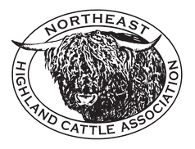
Student Prince & The Fort Restaurant
8 Fort Street
Springfield, MA 01103

Attendee Name(s):

1. 2.

3. 4.

5. 6.

Number attending banquet:

Adults & Children over 8 years of age: ______________@ $40.00 each
($42 if paid online)

Children under 8 years of age: _______________@ $10.00 each
($12 if paid online)

Total Enclosed: ________________

Please send a check payable to NEHCA by April 8th , 2022.
Mail to:
NEHCA
Attn.: Sue LeClar, 108 Woodgate Drive, Boonville NY 13309
Payments may also be made online at www.northeasthighlandcattle.org using PayPal ($2 surcharge per item will be assessed)

It is still necessary to send the banquet form to Sue indicating you have paid via PayPal.
If paying by PayPal, you can scan and email to sueleclar108@gmail.com.

